进去的时候是只标记包含的区间
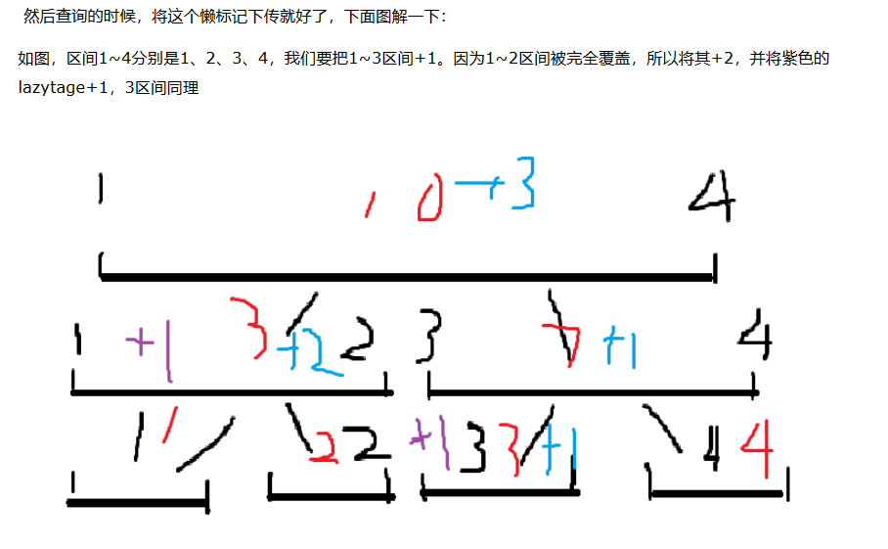

查询的时候，如果有交集，就往下push

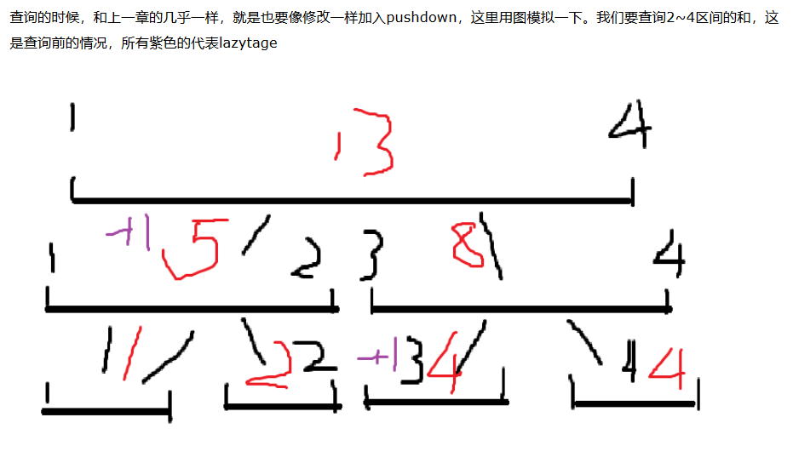

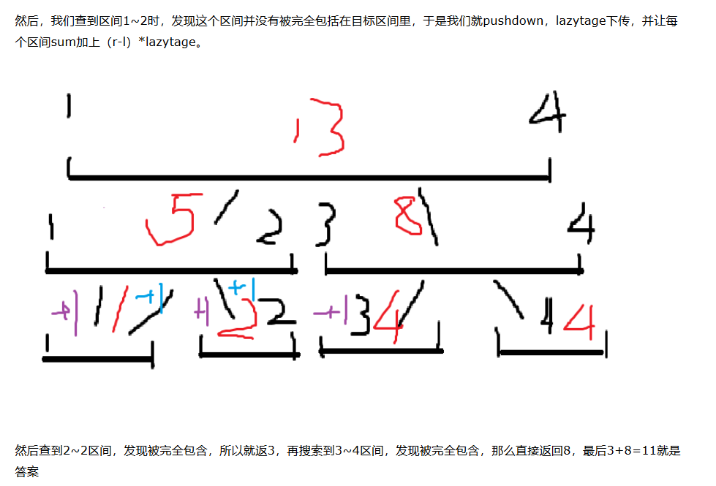

#include<iostream>
#include<cstdio>
#include<cstring>
#include<algorithm>
#include<map>
#include<vector>
#define ll long long
using namespace std;
ll n,m;
struct node
{
ll l,r;
ll lz;
ll sum;
}tree[2000003];
ll a[600000];
inline void build(ll i,ll l,ll r)
{ tree[i].lz=0;
tree[i].l=l;tree[i].r=r;
if(l==r) {
tree[i].sum=a[l];
return;
}
ll mid=(l+r)>>1;
build(i*2,l,mid);
build(i*2+1,mid+1,r);
tree[i].sum=tree[i*2].sum+tree[i*2+1].sum;
}
void push_down(ll i)
{
if(tree[i].lz!=0)
{
tree[i*2].lz+=tree[i].lz;
tree[i*2+1].lz+=tree[i].lz;
ll mid=(tree[i].l+tree[i].r)/2;
tree[i*2].sum+=tree[i].lz*(mid-tree[i*2].l+1);
tree[i*2+1].sum+=tree[i].lz*(tree[i*2+1].r-mid);
tree[i].lz=0;
}
return;
}
void add(ll i,ll l,ll r,ll k)
{
if(tree[i].r<=r&&tree[i].l>=l)
{
tree[i].sum+=k*(tree[i].r-tree[i].l+1);
tree[i].lz+=k;
return;
}
push_down(i);
if(tree[i*2].r>=l) add(i*2,l,r,k);
if(tree[i*2+1].l<=r) add(i*2+1,l,r,k);
tree[i].sum=tree[i*2].sum+tree[i*2+1].sum;
return;
}
inline ll search(int i,int l,int r)
{
if(tree[i].l>=l&&tree[i].r<=r) return tree[i].sum;
if(tree[i].r<l||tree[i].l>r) return 0;
push_down(i);
ll s=0;
if(tree[i*2].r>=l) s+=search(i*2,l,r);
if(tree[i*2+1].l<=r) s+=search(i*2+1,l,r);
return s;
}

int main()
{
scanf("%lld %lld",&n,&m);
for(int i=1;i<=n;i++) scanf("%lld",&a[i]);
build(1,1,n);
while(m--)
{
ll k,x,y;
scanf("%lld %lld %lld",&k,&x,&y);
if(k==1) {ll num;scanf("%lld",&num);add(1,x,y,num);}
if(k==2)
{ ll ans=search(1,x,y);
printf("%lld\n",ans);
}
}
return 0;
}

